

Register your 1st-5th grade dancer now for a fun three days of Broadway-themed Fun! This camp will explore musical theatre dancing and jazz while learning fun facts about popular shows. Your Broadway performers will light up the stage with their Marquee Mix -Up crafts and dance activities. At the end of camp, dancers will make their Broadway debut by performing show stopping routines inspired by each of the musicals we cover.

Cue the curtain, Broadway here we come!

Marquee

Mix Up

July 18, 19 & 20

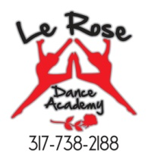

**Must pre register**

**317-738-2188**

**info@lerosedance.com**

**July 18, 19 &20**

**1st-5th graders**

**5:15-7:15pm**



**Cost: $75**

**for all 3 days**